

Statistiche 2022
Dati aggiornati al 31 dicembre 2022
Segreteria Generale






HOSPITALLER ORDER OF ST JOHN OF GOD
2025
STATISTICS
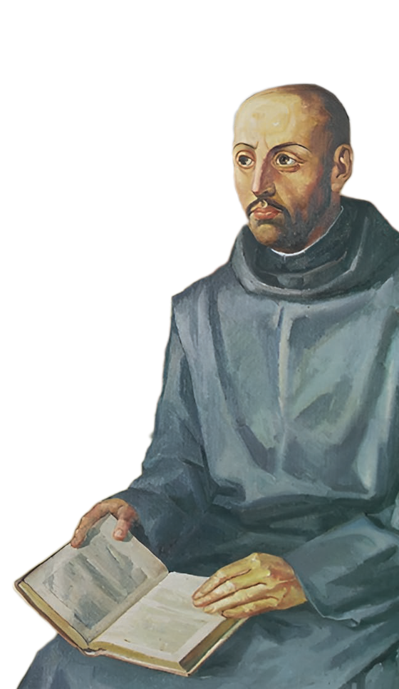

Updated to 31 December 2025
General Secretariat

PRESENTATION

This document gathers the 2025 Statistics of the Hospitaller Order
of Saint John of God, offering an updated and objective overview
of the life of the Brothers in the various Provinces and in the
contexts where Hospitality is present.

More than simple numbers, these data express a living story:
vocations that persevere, communities that grow, generations
that meet, and a mission that continues to serve the world of
suffering with creative fidelity.

The information collected here not only makes it possible
to analyse our reality responsibly, but also to discern more
clearly the challenges and opportunities that the future presents
to us, in the hope of continuing to build hospitality in a world
that is constantly changing.

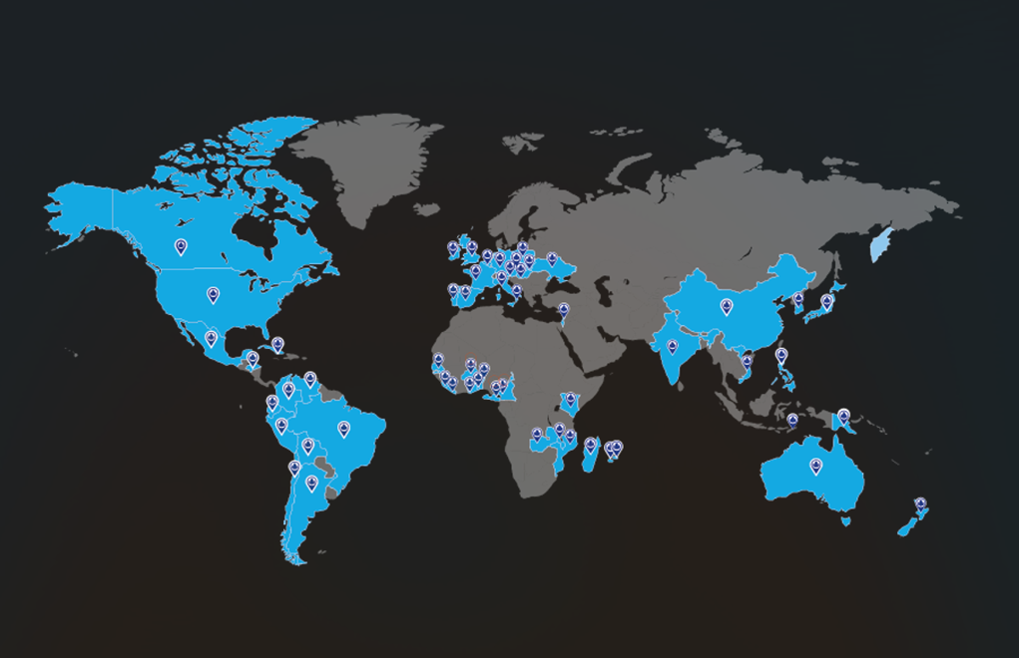
 936 Total number of Brothers in the Order, including Novices, distributed as follows by Religious Province:

 | PROVINCE | Solemn  Professed | Temporary Professed | Novices | Oblates | TOTAL
1 | Roman  To which the Prov. Del. of Philippines  belongs | 29 | 3 | - | 1 | 33
1 | Roman  To which the Prov. Del. of Philippines  belongs | 8 | 3 | - | - | 11
1 | To which the Prov. Del. of Papua New  Guinea belongs | 6 | - | - | - | 6
2 | Lombardy-Veneto | 29 | - | - | - | 29
3 | French | 28 | 24 | 6 | - | 58
4 | Poland | 65 | 1 | - | 2 | 68
5 | Portugal | 34 | 8 | 2 | - | 44
6 | Oceania | 15 | - | - | - | 15
7 | United States. | 10 | - | - | - | 10
8 | Vietnam | 74 | 12 | - | 1 | 87
9 | India | 40 | 5 | - | - | 45
10 | Korea  To which the Prov. Del. of Japan belongs | 24 | 1 | - | - | 25
10 | Korea  To which the Prov. Del. of Japan belongs | 4 | - | - | - | 4
11 | Africa St. Augustine | 58 | 18 | 11 | - | 87
12 | West European | 33 | 14 | - | - | 47
13 | Africa St. Richard Pampuri | 47 | 12 | 2 | - | 61
14 | Good Shepherd In North America | 18 | 1 | - | 1 | 20
15 | Latin America And the Caribbean | 89 | 4 | 5 | - | 98
16 | Spain | 157 | 2 | - | - | 159
17 | Central Europe | 42 | 4 | 2 | 2 | 50
 | TOTAL | 792 | 109 | 28 | 7 | 936
 | Solemn | Temporary | Novices | Oblates | TOTAL
31-12-2024 | 795 | 106 | 42 | 6 | 949
31-12-2025 | 792 | 109 | 28 | 7 | 936
DIFFERENCE | -3 | +3 | -14 | +1 | -13

The following changes in the total number of Brothers have occurred since the publication of the statistics at 31-12-2024:

 | Solemn | Temporary | Novices | Oblates | TOTAL
2000 | 1133 | 215 | 80 | 20 | 1448
2015 | 940 | 118 | 38 | 9 | 1105
2020 | 842 | 117 | 36 | 7 | 1002
2024 | 795 | 106 | 42 | 6 | 949
2025 | 792 | 109 | 28 | 7 | 936

The Brothers comprise
108
Priests:

Roman | 7 | United States | 2 | Africa St. R. Pampuri | 2
Lombardy-Veneto | 7 | Vietnam | 6 | Good Shepherd in N.A. | 3
French | 1 | India | 2 | Lt. America and the Caribbean | 17
Poland | 12 | Korea | 2 | Spain | 26
Portugal | 7 | Africa St. Augustine | 3 | Central Europe | 7
Oceania | - | West European | 4

Of whom 1 Bishop from the Province of Spain

The Brothers belong to
52
Different countries:

Argentina | 8 | England | 10 | Nicaragua | 2
Australia | 12 | France | 17 | Papua New Guinea | 6
Austria | 8 | Germany | 16 | Peru | 12
Belarus | 1 | Ghana | 20 | Philippines | 16
Benin | 23 | Guatemala | 2 | Poland | 68
Bolivia | 5 | Hungary | 7 | Portugal | 28
Brazil | 8 | India | 47 | Senegal | 14
Cameroon | 20 | Ireland | 18 | Sierra Leone | 13
Canada | 9 | Italy | 37 | Slovakia | 7
Cape Verde | 1 | Japan | 1 | Spain | 165
Chile | 8 | Kenya | 5 | Togo | 40
Colombia | 29 | Korea | 22 | Ukraine | 1
Congo | 3 | Liberia | 4 | Usa | 16
Croatia | 6 | Madagascar | 40 | Venezuela | 8
Cuba | 1 | Malawi | 19 | Vietnam | 92
Czech Republic | 4 | Mexico | 10 | Zambia | 5
East Timor | 14 | Mozambique | 3
Ecuador | 2 | New Zealand | 3
The average age of the brothers in the Order as a whole is
60 ANNI
distributed as follows:

 | PROVINCE | Solemn | Temp. | Novices | Oblates | TOTAL
1 | Roman | 58 | 32 | - | 70 | 56
2 | Lombardy-Veneto | 79 | - | - | - | 79
3 | French | 64 | 33 | 25 | - | 46
4 | Poland | 61 | 37 | - | 40 | 61
5 | Portugal | 69 | 30 | 31 | - | 60
6 | Oceania | 78 | - | - | - | 79
7 | United States | 80 | - | - | - | 78
8 | Vietnam | 55 | 34 | - | 41 | 51
9 | India | 56 | 32 | - | - | 77
10 | Korea | 65 | 44 | - | - | 50
11 | Africa St. Augustine | 52 | 33 | 28 | - | 52
12 | West European | 70 | 30 | - | - | 64
13 | Africa St. R. Pampuri | 52 | 29 | 25 | - | 44
14 | Good Shepherd  In N. A. | 77 | 61 | - | 61 | 58
15 | Lt. America And The Caribbean | 62 | 39 | 23 | - | 46
16 | Spain | 79 | 52 | - | - | 74
17 | Central Europe | 64 | 35 | 29 | 74 | 59
 | TOTAL | 65 | 33 | 28 | 60 | 60

The Order comprises a world-wide total of:

17 Provinces

Roman | United States | Africa St. Richard Pampuri
Lombardy-Veneto | Vietnam | Good Shepherd in N. A.
French | India | Lt. America and the Caribbean
Poland | Korea | Spain
Portugal | Africa St. Augustine | Central Europe
Oceania | West European

2 Provincial Delegations

Philippines  Dependent on the Roman Province | Japan  Dependent on the Korean Province

 | Provinces | Vice Province | General  Delegations | Provincial  Delegations
2000 | 22 | 1 | 5 | 6
2015 | 21 | 1 | 2 | 7
2020 | 22 | 0 | 1 | 7
2024 | 18 | 0 | 0 | 2
2025 | 17 | 0 | 0 | 2

The Brothers perform their apostolate in
424 APOSTOLIC CENTRES
of which 178 are canonically erected,
with the following breakdown by Province:

 | Province | Canonical  Centres | Others | TOTAL
0 | General Curia | 2 | - | 2
1 | Roman  To which the Prov. Del. of Philippines belongs  To which the Prov. Del. of Papua New Guinea belongs | 7 | 1 | 8
1 |  | 2 | 1 | 3
1 |  | 1 | - | 1
2 | Lombardy-Veneto | 11 | 4 | 15
3 | French | 10 | - | 10
4 | Poland | 13 | 24 | 37
5 | Portugal | 11 | 4 | 15
6 | Oceania | - | - | -
7 | United States. | 1 | 3 | 4
8 | Vietnam | 5 | 2 | 7
9 | India | 6 | 3 | 9
10 | Korea  To which the Prov. Del. of Japan belongs | 5 | 7 | 12
10 | Korea  To which the Prov. Del. of Japan belongs | 2 | 1 | 3
11 | Africa St. Augustine | 13 | 5 | 18
12 | West European | 2 | 44 | 46
13 | Africa St. Richard Pampuri | 5 | 2 | 7
14 | Good Shepherd In North America | - | 67 | 67
15 | Latin America And the Caribbean | 24 | 10 | 34
16 | Spain | 37 | 29 | 66
17 | Central Europe | 26 | 41 | 67
 | TOTAL | 178 | 246 | 424

The Canonical Centres

 | 2000 | 2015 | 2020 | 2024 | 2025
Canonical Centres | 217 | 226 | 184 | 179 | 178
Others | 150 | 229 | 220 | 244 | 246
TOTAL | 367 | 455 | 404 | 423 | 424

The Brothers are present in 5 continents, in the following
55 countries
in the following 155 communities:

EUROPE: 74

Austria | 4 | Germany | 3 | Portugal | 6
Czech, Rep. | 1 | Hungary | 2 | Slovakia | 1
Croatia | 1 | Ireland | 3 | Spain | 24
England | 2 | Italy | 9 | Ukraine | 1
Francia | 5 | Poland | 11 | Vatican | 1

ASIA: 22

China | 1 | Israel | 1 | Philippines |  | 2
East Timor | 1 | Japan | 2 | Vietnam |  | 5
India | 7 | Korea | 3

AFRICA: 27

Benin | 3 | Liberia | 1 | Senegal | 3
Burkina-Faso | 1 | Madagascar | 2 | Sierra Leone | 1
Cameroon | 2 | Malawi | 2 | Togo | 2
Equatorial Guinea | 1 | Mauritius | 1 | Zambia | 1
Ghana | 3 | Mozambique | 1
Kenya | 2 | Réunion, Island | 1

AMERICA: 29

Argentina | 2 | Cuba | 2 | Peru | 3
Bolivia | 2 | Chile | 2 | U.S.A. | 4
Brazil | 1 | Ecuador | 1 | Venezuela | 2
Canada | 3 | Honduras | 1
Colombia | 5 | Mexico | 1

OCEANIA: 3

Australia | 1 | New Zealand | 1 | Papua New Guinea | 1

The Communities

 | Europe | Asia | Africa | America | Oceania | TOTAL
2000 | 141 | 14 | 16 | 45 | 8 | 224
2015 | 111 | 25 | 22 | 45 | 6 | 209
2020 | 93 | 18 | 23 | 37 | 5 | 176
2024 | 79 | 22 | 27 | 29 | 4 | 161
2025 | 74 | 22 | 27 | 29 | 3 | 155

ADMISSIONS TO THE NOVIATE BY PROVINCE: 7

French | 2 | Africa St. R. Pampuri | 1 | Centrale Europe | 1
Africa St. Augustine | 1 | Lt. America and the Caribbean | 2

OBLATES 1

Poland | 1

TEMPORARY PROFESSIONS BY PROVINCE: 21

Roman | 1 | Vietnam | 1 | Lt. America and the Caribbean | 1
French | 3 | Africa St. Augustine | 3 | Spain | 1
Portugal | 6 | Africa St. Pampuri | 3 | Central Europe | 2

SOLEMN PROFESSIONS BY PROVINCE: 13

French | 1 | Africa St. Augustine | 3 | Lt. America and the Caribbean | 2
Portugal | 1 | West European | 3 | Central Europe | 1
Vietnam | 1 | Africa St. Pampuri | 1

DEATHS: 16
16 Solemn Professed of which 2 priests

Roman | 1 | Poland | 1 | Africa St. Augustine | 1
Lombardy-Veneto | 1 | Oceania | 1 | West European | 2
French | 1 | Korea | 1 | Spain | 7

DEPARTURES: 6

Solemn Professed | 1 | Temporary Professed | 5

Provenance of the Novices in 5 continents: 28

EUROPE: 3

Austrian | 1 | Portugal | 1 | Slovakia | 1

ASIA: 0

AFRICA: 20

Benin | 2 | Ghana | 1 | Madagascar | 6
Cameroon | 2 | Kenya | 2 | Senegal | 1
Cape Verde | 1 | Liberia | 2 | Sierra Leone | 3

AMERICA: 5

Guatemala | 2 | Nicaragua | 2 | Venezuela | 1

OCEANIA: 0

The Novices

 | Europe | Asia | Africa | America | Oceania | TOTAL
2000 | 22 | 25 | 4 | 25 | 4 | 80
2015 | 3 | 19 | 8 | 8 | 0 | 38
2020 | 2 | 12 | 21 | 1 | 0 | 36
2024 | 6 | 7 | 25 | 4 | 0 | 42
2025 | 3 | 0 | 20 | 5 | 0 | 28

From 2025, the religious, the Community and the apostolic work of Madang in Papua New Guinea ceased to belong to the Oceania Province and were incorporated into the Provincial Delegation of the Philippines, which belongs to the Roman Province.
From 2025, the 15 religious of the Oceania Province (Australia and New Zealand) were incorporated into the Korean Province.
From 1 September 2025, the Austrian and Bavarian Provinces were unified into the Central European Province.
In this statistical report, overseas territories (e.g., La Réunion) are presented separately for geographical distribution purposes, while remaining classified under their respective sovereign state (France).
It should be noted that the religious brother from Oceania had not been included in the 2024 statistics, as he was at that time recorded as having left the Order. Having received confirmation in 2025 of his actual belonging to the Order, he has been included in the count of the deceased for the year 2025.

